1.import java.util.Scanner;

import java.io.*;

public class CNC

{

public static void main(String[] args) {

Scanner scanner = new Scanner(System.in);

System.out.print("Enter the size of the array: ");

int size = scanner.nextInt();

int[] numbers = new int[size];

System.out.println("Enter the elements of the array:");

for (int i = 0; i < size; i++) {

numbers[i] = scanner.nextInt();

}

int count = 0;

for (int number : numbers) {

if (isComposite(number)) {

count++;

}

}

System.out.println("The number of composite numbers in the array is: " + count);

}

private static boolean isComposite(int number) {

if (number <= 1) {

return false;

}

for (int i = 2; i <= Math.sqrt(number); i++) {

if (number % i == 0) {

return true;

}

}

return false;

}

}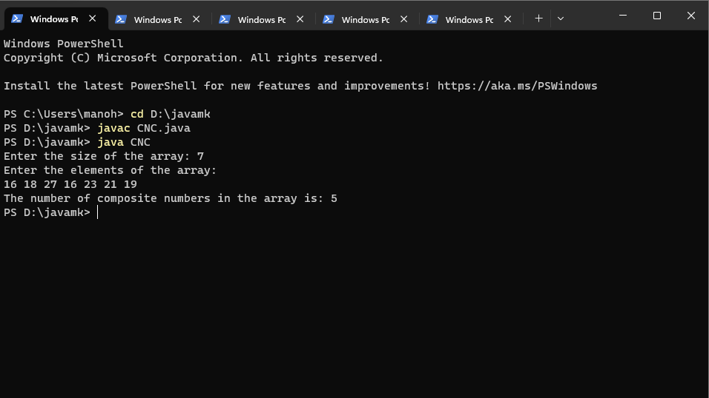

2.matrix addition

import java.util.*;

import java.io.*;

class addmatrix

{

public static void main(String args[])

{

Scanner sc=new Scanner(System.in);

int i,j,row,col;

System.out.println("enter the number of rows");

row=sc.nextInt();

System.out.println("enter the number of col");

col=sc.nextInt();

int max1[][]=new int[row][col];

int max2[][]=new int[row][col];

int add[][]=new int[row][col];

System.out.println("enter the first matrix");

for(i=0;i<row;i++)

{

for(j=0;j<col;j++)

max1[i][j]=sc.nextInt();

System.out.println();

}

System.out.println("enter the second matrix");

for(i=0;i<row;i++)

{

for(j=0;j<col;j++)

max2[i][j]=sc.nextInt();

System.out.println();

}

for(i=0;i<row;i++)

for(j=0;j<col;j++)

add[i][j]=max1[i][j]+max2[i][j];

System.out.println("addition of two matrices is");

for(i=0;i<row;i++)

{

for(j=0;j<col;j++)

System.out.print(add[i][j]+"\t");

System.out.println();

}

}

}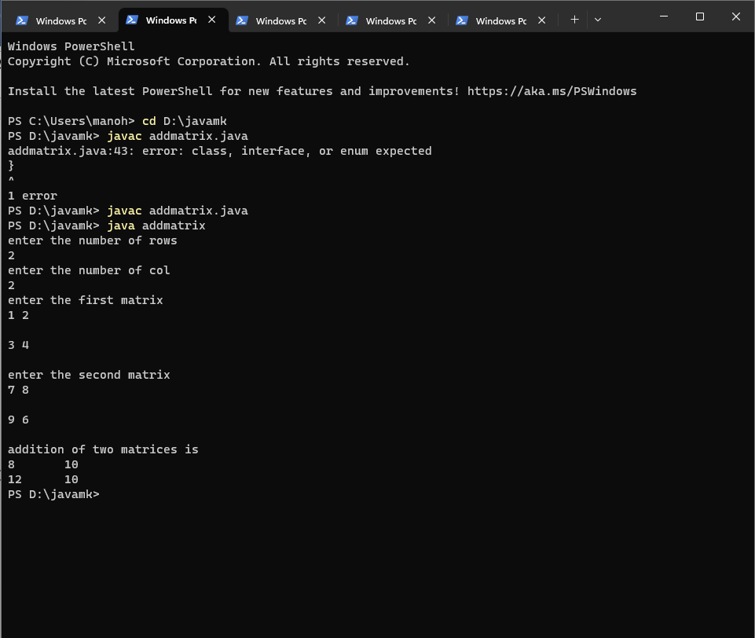

**3.square root**

import java.util.Scanner;

public class SquareRoot

{

public static void main(String[] args) {

Scanner scanner = new Scanner(System.in);

System.out.print("Enter a non-negative integer: ");

int x = scanner.nextInt();

int result = sqrt(x);

System.out.println("The square root of " + x + " is " + result);

}

private static int sqrt(int x) {

if (x == 0) {

return 0;

}

int left = 1;

int right = x;

int result = 0;

while (left <= right) {

int mid = left + (right - left) / 2;

if (mid <= x / mid) {

left = mid + 1;

result = mid;

} else {

right = mid - 1;

}

}

return result;

}

}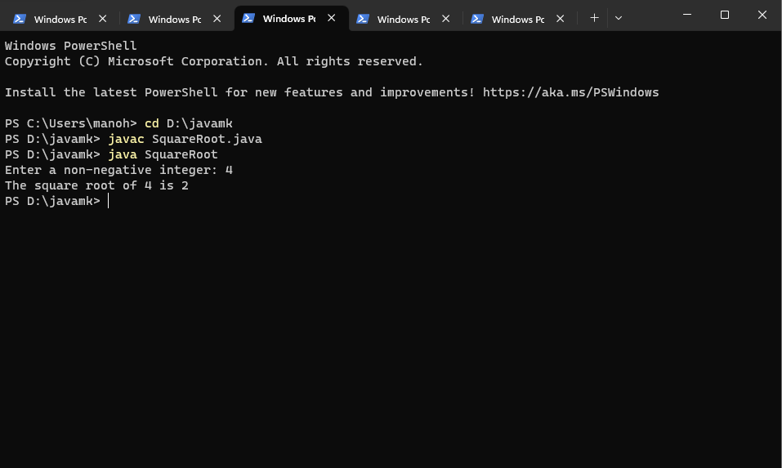

4.palindrome

import java.util.Scanner;

public class Palindrome {

public static void main(String[] args) {

Scanner scanner = new Scanner(System.in);

System.out.print("Enter an integer: ");

int x = scanner.nextInt();

boolean result = isPalindrome(x);

System.out.println("The integer " + x + " is a palindrome: " + result);

}

private static boolean isPalindrome(int x) {

if (x < 0) {

return false;

}

int original = x;

int reversed = 0;

while (x != 0) {

int digit = x % 10;

reversed = reversed * 10 + digit;

x /= 10;

}

return original == reversed;

}

}

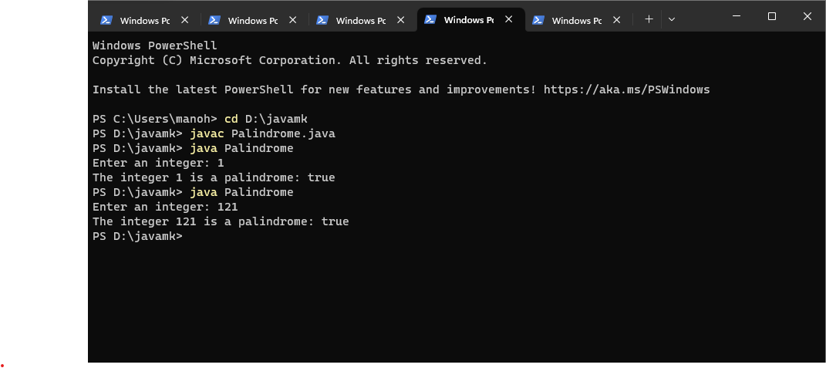

**5.error debug**

import java.util.*;

class age{

public static void main(string arcs[]){

Scanner scan=new scanner (System.in);

System.out.println(&quot;Enter the age of person&quot;);

int user_age=scan.next Int();

System.out.printn(&quot;The age of person is&quot;+user_age);

if(user_age&gt;18)

{

System.out.println(&quot;You are eligible to Vote&quot;);

}

else{

System.out.println(&quot;You are not eligible to vote and ..for you &quot; + (18 - user_age) + &quot; years

are left to be eligible&quot;);

}

}

}

Answer

import java.util.*;

class Age {

public static void main(String[] args) {

Scanner scan = new Scanner(System.in);

System.out.println("Enter the age of the person:");

int userAge = scan.nextInt();

System.out.println("The age of the person is " + userAge);

if (userAge >= 18) {

System.out.println("You are eligible to vote.");

} else {

System.out.println("You are not eligible to vote, and " + (18 - userAge) + " years are left to be eligible.");

}

}

}